Raees Jaffar

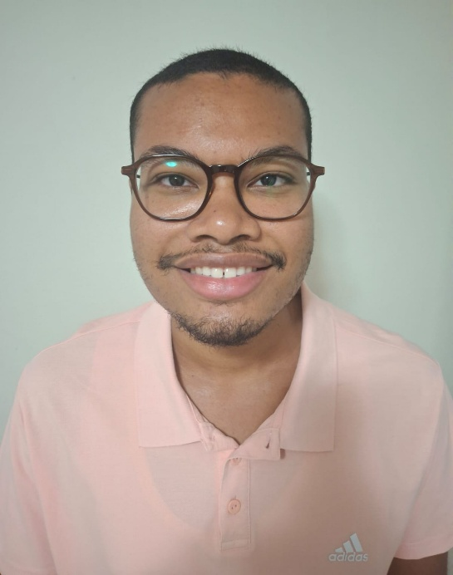

PROFESSIONAL PROFILE
I am currently studying multimedia applications at Cape Peninsula
University of Technology (CPUT) as part of an IT Diploma Program.
I have built an excellent understanding of digital design, multimedia
production and web development and I can take a concept and
create a working and visually appealing digital solution for a
business. My passion lies in technology, creativity, and innovation
and I continue to strive to produce top quality work. I am adaptable
and disciplined, possess excellent communication and people skills,
can work successfully both alone and within a team, and add value
through my creativity or technical skills.

WORK EXPERIENCE

LEADER OF AN ACADEMIC PROJECT TEAM
Cape Peninsula University of Technology | 2023 – 2026

- Managed and organized the execution of multi-faceted multimedia and IT based group projects throughout
individual course modules.

- Developed project timelines by allocating necessary tasks to group members and ensuring that all deliverables were met
at both academic and professional levels.

- Created multimedia resources; in particular, digital graphics, presentations and promotional-type products.

- Created procedural documentation for each project including description/technical outline type documents, proposal and final report documents.

Presented the project deliverables to both faculty and fellow
students.

CONTACT

Location: Cape Town, South Africa

Cellphone: +27762283930

Email: 222668962@mycput.ac.za

LinkedIn: https://www.linkedin.com/learning /?u=2256146

GitHub: https://github.com/Ra-ees

EDUCATION

Plumstead High School [2017 – 2021] - National Senior Certificate

Cape Peninsula University of Technology [2023 – 2026] - DIP: ICT in Multimedia Applications

TECHNICAL SKILLS
- HTML, CSS, Responsive Web Design

- Basic Analytics Interpretation

- Canva

- Video Editing

- Vector Graphic Design

- Digital Image Manipulation

- Layout Design

- Microsoft Office (Word, Excel, Access,
PowerPoint, Outlook)

- Content Creation
SKILLS
Graphic Design
HTML
CSS
UI Design
UX Principles
Video Editing
Content Creation
Strategic Planning
Leadership
Communication
Teamwork
Problem Solving
Time Management
Attention to Detail
Adaptability
Project Planning

DEVELOPED AND DESIGNED WEB-BASED APPLICATIONS AND
EDUCATIONAL RESOURCES (ACADEMIC PROJECTS)
Cape Peninsula University of Technology | 2023 - 2026

- Developed websites by writing HTML, CSS and Javascript code.

- Used user interface/user experience (UI/UX) standards to
create better user experience and increased accessibility.

- Designed and implemented multimedia components to make
interactive and visually appealing objects.

- Ensured design functioned and was usable through testing and
revision.

SOCIAL MEDIA CONTENT CREATOR
YouTube, TikTok, Instagram | 2024 - 2026

- Developed and managed original digital content across
multiple social media platforms.

- Designed thumbnails, short-form videos, and visual assets
aligned with platform trends.

- Planned content strategies, captions, and posting schedules to
increase audience engagement.

- Analyzed audience engagement to refine content performance
and creative direction.

REFERENCES
Meagan Hamman
Cape Peninsula University of Technology
Multimedia Design Lecturer
+27214609010

Shamil Khan
Woodside Village for the disabled
Events Coordinator
+27662038324

VOLUNTEERING EXPERIENCE

Old Age Home Volunteering

- Aided senior residents with their daily activities and provided opportunities for socialization.

- Exhibited empathy, patience, and strong interpersonal
communication skills; and contributed positively towards
the well-being of other members of the community
through team and service-based activities.

Community Volunteer (Mowbray Cemetery)

- Helped with a community cleanup and the environmental
upkeep of facilities within the community.

- Assisted in preserving the environment through organized
volunteer activities.

